|  |  |  |
| --- | --- | --- |
| Contact: Steven Swensen  Windsor Locks  High School  Phone 860-292-5713  Fax 860-292-5039  [sswensen@wlps.org](mailto:sswensen@wlps.org) | 58 S. Elm St.  Windsor Locks, CT 06096 | Windsor Locks  High School |

Press Release

# **Windsor Locks High School Students**

# **BRIDGES Program**

Windsor Locks, CT September 30, 2015: On September 23rd and 24th Windsor Locks High School had the pleasure of sending twenty-seven students to participate in the BRIDGES Program. BRIDGES is a two-day bullying prevention, prejudice reduction, team building and leadership development program that empowers young people to create positive change in their lives and in their school. Students and three teachers came together to explore diversity and examine ways to make the Windsor Locks community a safer, more inclusive, and bias-free place for everyone. Students and staff participated in a variety of team-building activities and self-reflections, and brainstormed ways to enhance the climate of Windsor Locks High School and the community as a whole. One student, Brandon Spears, said, “BRIDGES was great! After attending I realized that the program would be a great help to all students!” The students who participated in the program will be involved in a variety of leadership endeavors and activities throughout the year at WLHS.

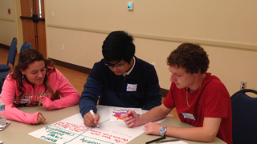In the picture to the left, (from left to right) Tiffani Masse and Benjamin Conniff are helping fellow participant Alvin Khoxayo during a brainstorming session on media stereotypes.

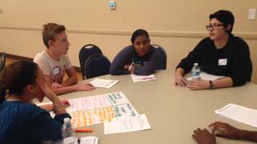

At a group roundtable discussion, WLHS students (from left to right) Ashley O’Brien, Ryan Tarko, Marie Hamilton, and Cristina Crespo are preparing to present their findings to the whole group.